Name | Client Care Favourites Screen
Version | 1
Owner | Morné Homan
Component Category | Application  #horizon #clientcare
Component Type | User Interface
Responsibilities | Front-End for accessing frequent support queries.
Authentication * | IDP
Authorization | - clientcare-agent  - clientcare-teamleader  - clientcare-manager  - clientcareadmin-agent  - clientcareadmin-teamleader  - clientcareadmin-manager
Collaborators | Dependency Integration layer  Client Care Channel Service  http://cb0218:8080/tfs/CapitecBank/BSC%20Components/_git/Capitec.BSC.Horizon.ChannelService?path=%2FArtifacts%2FContracts%2FCapitec.BSC.ClientCare_V1.yaml&version=GBdevelop  - /clientcare/favourites/v1/landing  Screen Inputs:  - Caller Information  - From state  - Incoming Call Details  - From state  - Verification Status  - From state  - Landing Page data  Screen Outputs  - Verify Clicked – To verify an unverified client, starts verification flow  - Option Clicked – Starts the flow for whichever option was clicked (stop card, debicheck etc.)  Screen heavily dependent on state, see supporting doc links for documentation
Release Notes | << Link >>
Supporting Docs | Description | Link
Supporting Docs | Screen | 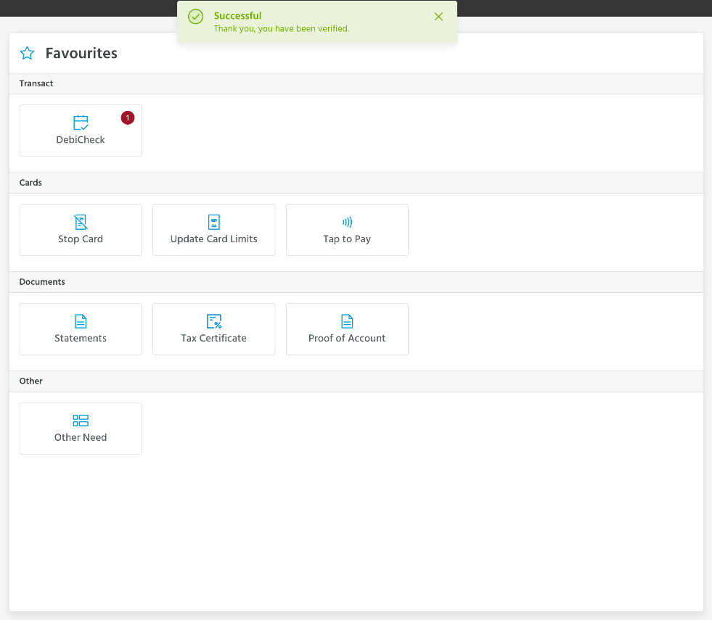
Supporting Docs | OpenAPI | http://cb0218:8080/tfs/CapitecBank/BSC%20Components/_git/Capitec.BSC.Horizon.ChannelService?path=%2FArtifacts%2FContracts%2FCapitec.BSC.ClientCare_V1.yaml&version=GBdevelop
Supporting Docs | State Object Description | https://confluence.capitecbank.co.za:8443/x/2QcwFw  http://cb0218:8080/tfs/CapitecBank/BSC%20Components/_git/Capitec.BSC.Horizon.UI?path=%2Fsrc%2Fstore%2FHorizonStore.js&version=GBdevelop
Technical Debt | Description |  |  | Remediation Plan
Relevant Standards adhered to | REST  Product Service Standard  Swagger
Test cases & Results | Category |  | Link
Test cases & Results | Integration Test
Test cases & Results | Soak Test
Test cases & Results | Penetration Test
Test cases & Results | Load Test
Test cases & Results | Automate Test

